Program 9_1:

Test Plan:

|  |  |  |  |
| --- | --- | --- | --- |
| **Cases** | **Input** | **Expected Result** | **Actual Result** |
| Input int1 | 1 | Next step | Next step |
| While(valid) | Repeat loop if valid stays true | Repeat loop | Repeat loop |
| Input int(1/2) | 1.2 | “Please enter an integer.” | “Please enter an integer.” |

**Program 9_1 screenshot/flowchart:**

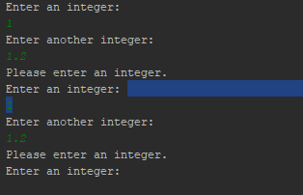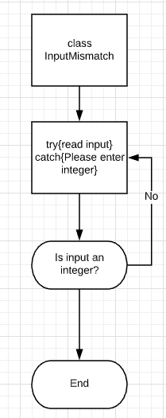

UML:

|  |
| --- |
| **InputMismatch** |
| +Boolean valid |
| +main() |

**Project 9_2**

Test Plan:

|  |  |  |  |
| --- | --- | --- | --- |
| **Cases** | **Input** | **Expected Result** | **Actual Result** |
| Enter a binary string: | 1011100 | 92 | 92 |
| Enter a binary string: | 123dogs | Not a binary string. | Not a binary string. |

Screenshots:





UML:

|  |
| --- |
| **NumberFormat** |
| +double j  +double i |
| +bin2Dec(String binaryString): int  +main(): void |

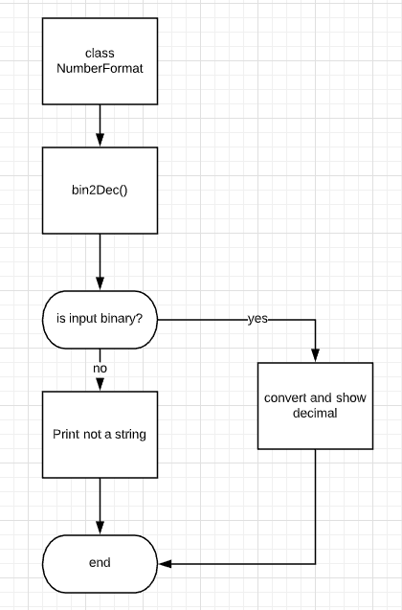

**Project 9_3**

UML:

|  |  |
| --- | --- |
| **RmvText** | **readFile** |
|  | +Scanner |
| +main() | +openFile()  +readFile(String word)  +closeFile() |

Test Plan:

|  |  |  |  |
| --- | --- | --- | --- |
| **Cases** | **Input** | **Expected Result** | **Actual Result** |
| Remove word John | John | Hello my name is  likes to cook food  is also the name | Hello my name is  likes to cook food  is also the name |
| Check if file exists | "/Users/Arman Khan/Desktop/JohnSample.txt" | Continues with program | Continues with program |

Screenshot:

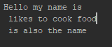

With command line argument entered.

Original textfile:

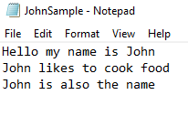

Flowchart:

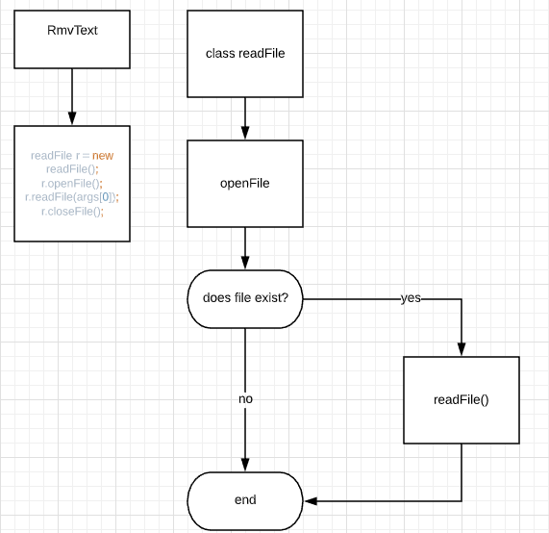

Lessons learned:

Exception handling and reading input and writing output are both very valuable skills. Difficult to learn but easier to master.